 | Google Chromebooks:  An Introduction for Parents | 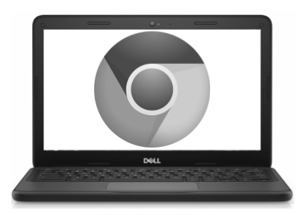
What is a Chromebook?
A Chromebook is a laptop that allows you to use the Chrome Internet Browser to access anything on the web, and G Suite applications such as Docs, Drive, and Google Classroom. You can log in to this device with your @philasd.org account to connect with your teachers through Google Classroom and access your classwork.  As a cloud-based device, a Chromebook does not have a hard-drive and therefore doesn't require Windows or iOS operating systems or installed software to function. Once you connect your machine to the internet, you will be able to get started! | 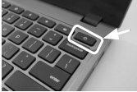

How to Activate & Log-In to your Account
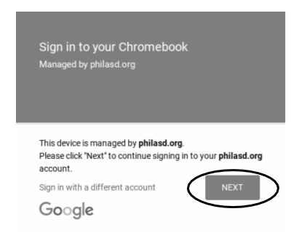
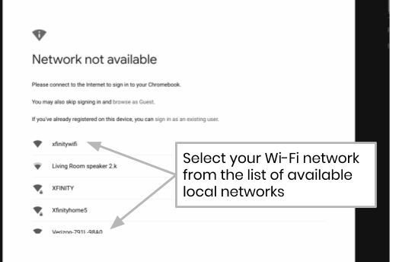
Step 1 → Turn on the Chromebook by pressing the Power Button in the upper right corner of the keyboard (see above). You should see a screen inviting you to Sign in to your Chromebook (shown left). Select “Next”.

Step 2 → Enter your username (Student ID#)

Step 3 → Enter your school password

Step 4 → Click “Sign in”

Additional Note → If you get a wireless connection error, please be sure to choose your home network.

Adding Wi-Fi Networks
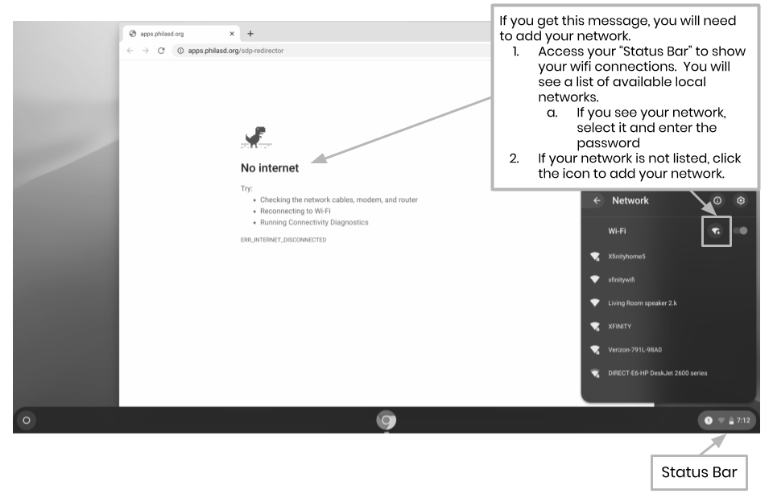
If you successfully log in to your account but need to add your Wi-Fi network, you will see this message when you activate your Chrome Browser. Follow the steps below to add your home network. Please note that you will need the SSID (or name) of the network you want to join, and the password to that network to gain access.

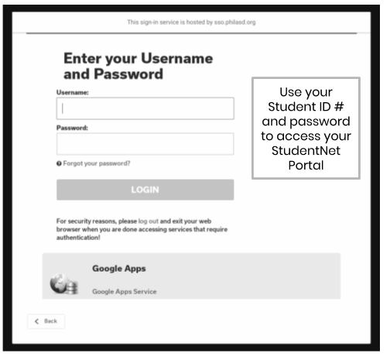
Log-in to StudentNet

Step 1 → Access your Chrome Internet Browser

Step 2 → Enter your username (Student ID#)

Step 3 → Enter your school password

Step 4 → Click “Login”

Accessing Resources & Google Classroom in Infinite Campus
Once logged in, select the “Message Center” from the menu on the left side of the screen. From here, you will be able to access the Student Launchpad, applications, online textbooks, and G Suite applications such as Drive, Docs, and Google Classroom.
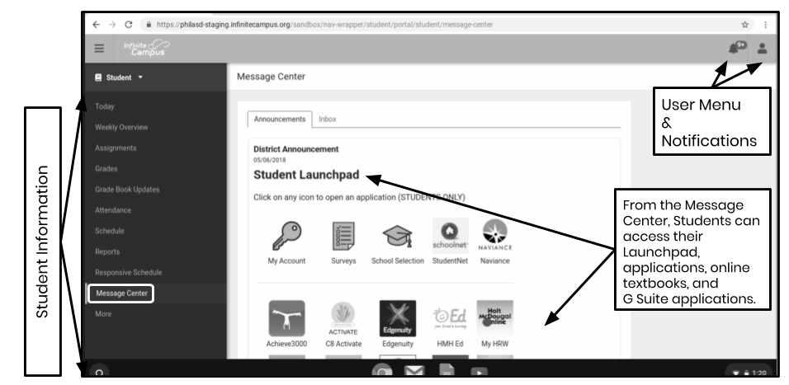

How to Access Chrome & Navigate the Chromebook Desktop
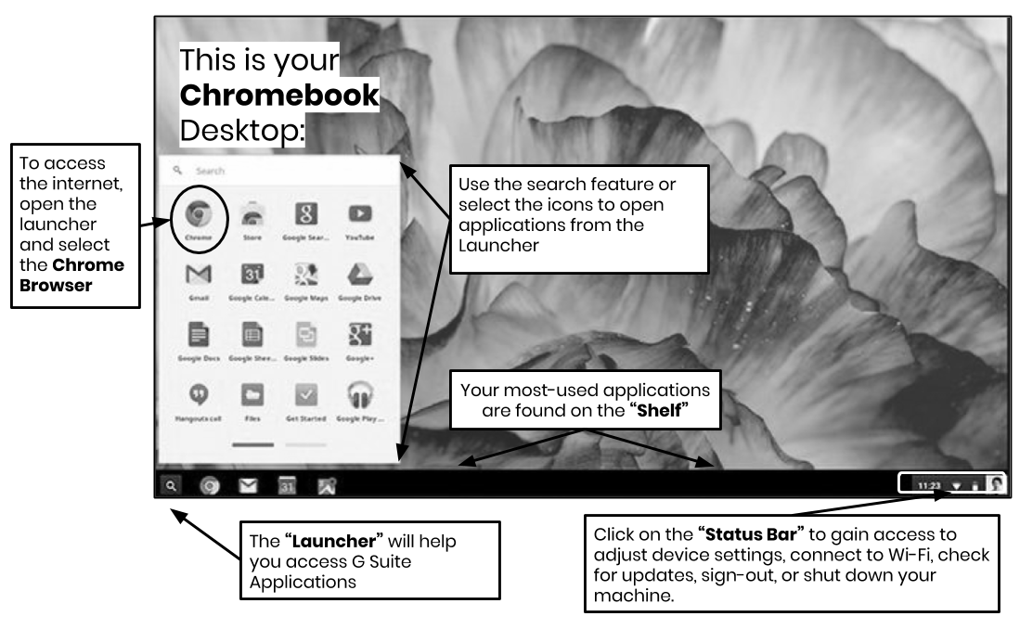

When looking at the Chromebook Desktop there are three main areas that users need to access: (1) the “Launcher” provides access to the Chrome Browser and other G Suite Applications, (2) the “Shelf” will show your frequently used applications, and (3) the “Status Bar” which expands into a menu that allows you to adjust settings for your device, monitor your Wi-Fi, sign-out and turn the Chromebook off.

