Google Classroom:
An Introduction for Parents
If you would like to login to your child’s Google Classrooms to see and access digital learning activities, follow these directions:

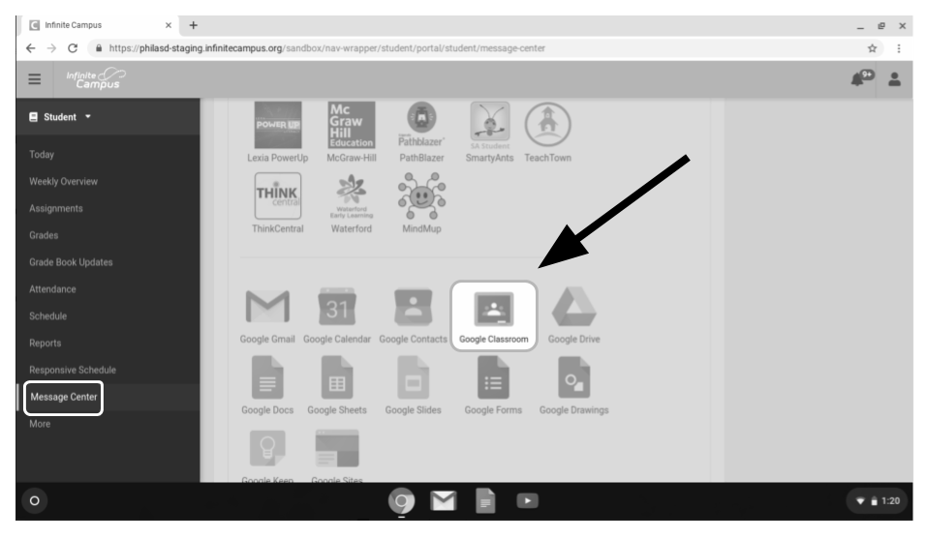
- Turn on your child’s Chromebook and login with their school district username (student id#) and password.
- Access Google Classroom through Infinite Campus:

  - Select the Message Center to access student resources. Scroll until you find G Suite Applications and select Google Classroom.

  - This will bring you to your student’s classroom dashboard, where you will see cards for each class as shown below. Select a class by clicking on the card.

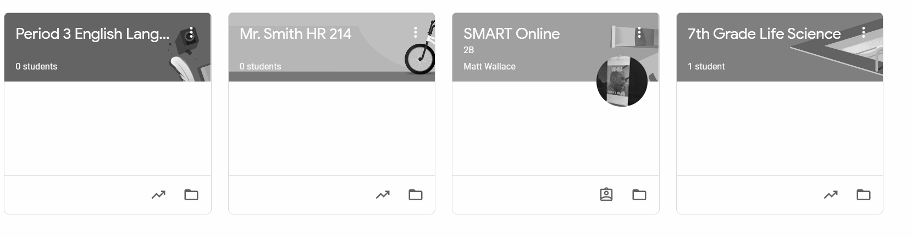

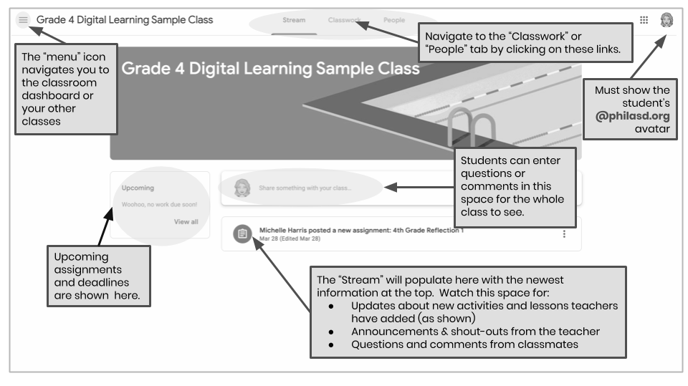
- Once you have opened up your class, you will be brought to the Classroom homepage, otherwise known as the “Stream”. See the image below to understand how to navigate and monitor this page:
- Each Google Classroom has three main pages: the “Stream”, “Classwork”, and “People”:
  - The Stream is your classroom home page. Watch this space for:
    - Updates about new materials and assignments
    - Announcements from your teachers
    - Questions and comments from students
  - The Classwork tab is where teachers will post assignments and share class materials for students to access.
  - The People tab lists the members of your class, including teachers and classmates, and gives you the option to email them directly.

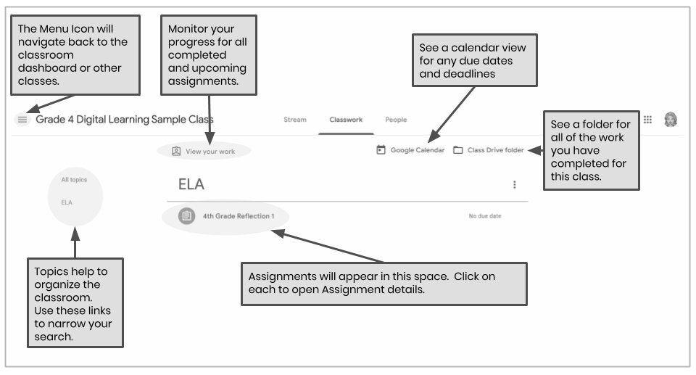
- As you access the Classwork tab, you will see a list of assignments and materials, organized by topic.

- Click to expand an assignment to access instructions, assignment details, and hyperlinks to the activities and resources. See the image below to better understand how to navigate the assignment windows, communicate with your classmates and teacher, and submit your work.
